5.80: If the block were to remain at rest relative to the truck, the friction force would need to cause an acceleration of 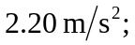 however, the maximum acceleration possible due to static friction is 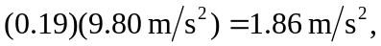 and so the block will move relative to the truck; the acceleration of the box would be 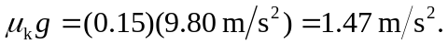 The difference between the distance the truck moves and the distance the box moves (i.e., the distance the box moves relative to the truck) will be 1.80 m after a time

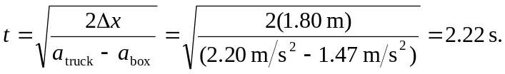

In this time, the truck moves Note that an extra figure was kept in the intermediate calculation to avoid roundoff error.

